2020 ENGINEERING E XCELLENCE AWARDS
CALL FOR
ENTRIES

2020 Engineering Excellence Awards
ENTRY FORM

Check the appropriate Award Category box for your entry.
(See page seven for descriptions of each category.)
A ☐ Studies, Research & Consulting Engineering Services
B ☐ Building/Technology Systems
C ☐ Structural Systems
D ☐ Surveying and Mapping Technology
E ☐ Environmental
F ☐ Water and Waste Water

G ☐ Water Resources
H ☐ Transportation
I ☐ Special Projects
J ☐ Small Projects
K ☐ Energy
L ☐ Industrial and Manufacturing Processes
& Facilities
☐ SMALL FIRMS PROJECTS

Note: A project may be entered into only one (1) category. It is common for a project to be eligible in more than one category. It is up to the entrant to determine which category best fits the submission.

Firm Information

Firm Name (If more than one, please include all firm names.) Click here to enter text.
Firm Representative(s) Click here to enter text.
Address Click here to enter text.
City Click here to enter text. State Click here to enter text. Zip Click here to enter text.
Phone Click here to enter text. Cell Click here to enter text. Email Click here to enter text.

As firm representative, I hereby authorize submission of this project into the ACEC NE 2020 Engineering Excellence Awards.
Signature Click here to enter text. Date Click here to enter text.
Type in or insert a scanned signature.

Project Information

Project Title (No more than 20 words)
Click here to enter text.
Client(s)
Click here to enter text.
Client Representative(s)
Click here to enter text.
Client Representative Signature: Click here to enter text.
Type in or insert a scanned signature
Client Address No P.O. Boxes Click here to enter text.
City Click here to enter text. State Click here to enter text. Zip Click here to enter text.
Project Completion/Use Dates
Scheduled Click here to enter text. Actual Click here to enter text.
Category A Costs (Studies, Research and Consulting Engineering Services)
Budgeted $ Click here to enter text. Actual $ Click here to enter text.
Construction Costs
Note: If your firm was responsible for the entire project, then the Entrant’s Portion of the Total Project Construction Budget should equal the Total Project Construction Budget. If your firm was not responsible for the entire project, then the Entrant’s Portion of the Total Project Construction Budget should be only the amount of the project construction budget for which your firm was responsible.

Total Project Budget $ Click here to enter text.
Total Project Actual $ Click here to enter text.
Entrant’s portion of Total Project Budget $ Click here to enter text.
Entrant’s portion of Total Project Actual $ Click here to enter text.

Was the project awarded through QBS process? Check box. Yes ☐ or No ☐

Project Description

Complete the following sections. Text fields will expand to accommodate your response and it will allow formatting. Reference the Judging Criteria Prompts definitions in this document (page 8). Please note there is an Optional Graphics section at the end of the form where a location map and up to five additional graphs may be added.

A) Role of entrant’s firm in the project:
Click here to enter text.
B) Firm Names, Locations, and Roles of Key Participants Include contractors, subcontractors, other engineers, architects and designers significantly involved in the project.
Click here to enter text.
C) Entrant’s contribution in the following five (5) areas (please reference Judging Criteria Prompts, page 8):
Uniqueness and/or Innovative Applications of New or Existing Techniques:
Click here to enter text.
Future Value to the Engineering Profession and Enhanced Public Awareness/Enthusiasm of the role of Engineering:
Click here to enter text.
Social, Economic, and Sustainable Development Considerations:
Click here to enter text.
Complexity:
Click here to enter text.
Fulfillment of Client/Owner Needs:
Click here to enter text.
D) 250-WORD Project Description. Describe the project in non-technical language for use in announcements and publications. Summarize the project in a compelling way for a general audience.
Click here to enter text.

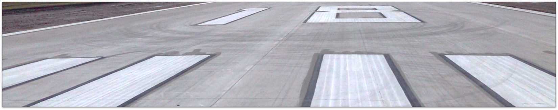
Photos/Graphics

Six Different Photos or Graphics In the matrix below, click on the icon and insert up to six photos sized to 6” x 4.5” or 4.5” x 6” at 300 dpi. Include three photographs of the completed project and three photographs of the planning, start-up, and/or construction phase. After inserting into the placeholder you can resize the pictures to final dimensions, either horizontal or vertical. Add the photo caption below it.

NOTE: Small Firm projects require a minimum of two photos and captions.
Photo 1:
Photo 1 Caption:
Click here to enter text.
Photo 2:
Photo 2 Caption:
Click here to enter text.
Photo 3:
Photo 3 Caption:
Click here to enter text.

Photo 4:
Photo 4 Caption:
Click here to enter text.
Photo 5:
Photo 5 Caption:
Click here to enter text.
Photo 6:
Photo 6 Caption:
Click here to enter text.

Mandatory for Category A: Please email one pdf of the final project report containing the findings to anita@acecnebraska.org by the due date. Please reference firm name, EEA2020, and project title in the email.

Optional Graphics. JPEGs of a Location Map and up to five additional Graphs/Charts may be included.

Location Map

Additional Graphs/Charts referenced in the text
Click here to enter text.

AWARD APPLICATION CHECKLIST

- ☐ Official Entry Form Completed and Signed
Double check these sections:
☐ Project Entry Information (pages 2-3)
☐ Photos Sized Correctly (pages 4-5) 6”x 4.5” or 4.5” x 6” at 300 dpi

- ☐ Project Client and Owners Signatures Page (separate page)

- ☐ Small photographic display panel done in PowerPoint (separate file)
☐ Title Entered (Typed EXACTLY as wanted printed on certificates and in publications.)

- ☐ Entry Fee Payment
☐ Check mailed with the applicable entry fee payable to ACEC Nebraska

- ☐ Submitted materials electronically. NOTE *New* Instructions for Uploading Entries.
  - Collect all files into one folder and then Name it with the following:
(Category letter (SPACE) Firm name (SPACE) followed by Project Title.
Example: C Firm Name Project Title
  - ZIP the folder.
  - Login to box.com using the following username and password:
    - username: uploads@acecnebraska.org
    - pw: ACEC@123!
  - Click INTO the UPLOADS FOLDER. This is very important! If you don’t place your files in the uploads folder, other firm representatives uploading their files will be able to view your files.
  - Click upload and then upload the zipped folder
  - Logoff
  - Email anita@acecnebraska.org and let us know the entry has been uploaded.

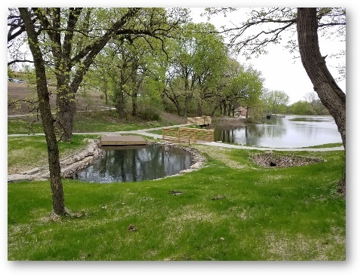
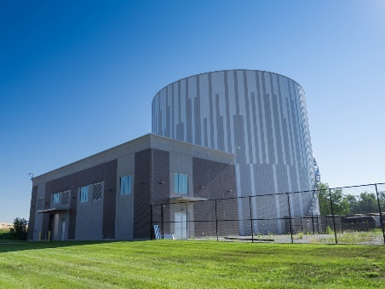
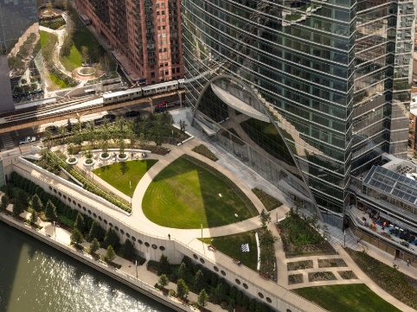

List of Award Categories

Category A – Studies, Research & Consulting Engineering Services  Projects not involved with the preparation of construction documents. Non-design services engineering including, but not limited to:  - New Products, Materials and Technologies  - Basic Research and Studies  - Expert Testimony  - Computer/Software Technology  - Technical Papers | Category H – Transportation  - Highways  - Railroads  - Airports  - Marine/Ports  - Public Transit  - Freight  - Intermodal Facilities
Category B – Building/Technology Systems  - Mechanical/Electrical  - Computer Technology  - Communications  - Acoustics  - Software Systems  - Sustainability or carbon neutrality  - Efficiency certification standards, e.g. LEED  - Energy efficiency-new and retrofit  - Secure facilities (military, research, correctional) | Category I – Special Projects  - Safety/Security  - Land Development  - Oil and Gas  - Nuclear  - Corrosion Protection  - Mining, Metallurgy and Mineralogy  - Program and Construction Management  - Energy Production/Conservation  - Industrial Processed/Materials Handling
Category C – Structural Systems  - Foundations  - Tunnels  - Buildings  - Seismic Design  - Towers  - Bridges  - Sports Facilities | Category J – Small Projects  Projects under $1 Million from any area of engineering.
Category D – Surveying and Mapping Technology  - Geometrics, ALTA, land title, and rights surveys  - Control, GPS, monitoring or construction surveying  - Survey mapping, GIS/LIS, photogrammetry | Category K – Energy  - Transmission and Distribution  - Demand Side Management  - Energy Usage Reduction Programs  - Energy Efficiency – New and Retrofit  - Energy Storage Technologies  - Power Generation  - Cogeneration  - Renewable Energy
Category E – Environmental  - Hazardous Waste  - Solid Waste  - Restoration/reclamation/remediation  - Air Quality  - Noise  - Recycling  - Waste pond management  - Carbon sequestration and trading  - Mitigation | Category L – Industrial & Manufacturing Processes and Facilities  - Petrochemical  - Biotech  - Manufacturing  - Heavy Industry  - Industrial Waste  - Materials Handling  - Mining, Metallurgy, Mineralogy
Category F – Waste and Wastewater  - Water Supply/Distribution/Treatment  - Industrial Waste  - Residuals Management  - Wastewater Collection/Treatment and Disposal | Small Firms Projects  Any ACEC NE engineering or surveying firm up to 25 employees are eligible to compete against other small firm projects. Submit a minimum of two photos with captions, with a maximum of six.
Category G – Water Resources
- Hydraulics and Hydrology
- Irrigation
- Storm Water Management
- Erosion Control
- Recreational Facilities
- Flood Control and Dams

Judging Criteria Prompts

Each submission will be evaluated based on the following five categories, which are key elements of the project description text on the Entry Form. These questions are intended to help you brainstorm award submittal content to effectively address each category of judging criteria. They are not meant to be directly answered in your submittal and some questions may not apply to your entry.

1.ORIGINAL OR INNOVATIVE APPLICATION OF NEW OR EXISTING TECHNIQUES (Rating – 20%)
•Does the entry demonstrate the use of a new science or a breakthrough in general knowledge of engineering?
•Does the entry represent a unique application of new or existing technology, techniques, materials or equipment?
•How was the solution developed for this project different from a similar project?

2.FUTURE VALUE TO THE ENGINEERING OR SURVEYING PROFESSION (Rating – 20%)
•Will the entry redefine current engineering or surveying thinking?
•How could someone else use what your firm did to solve a similar problem?

3.SOCIAL, ECONOMIC, AND SUSTAINABLE DESIGN CONSIDERATIONS (Rating 20%)
•Do the solutions identified produce secondary benefits of value to the community and/or environment?
•Does the entrant’s approach provide society with social, economic, or sustainable development benefits?
•Does the entrant’s contribution to the project improve the health, safety, or welfare of the public or affected environment?

4.COMPLEXITY (Rating – 20%)
•Did the entry successfully address highly complex criteria or unique problems?
•Were extraordinary problems of site, location, hazardous conditions, project requirements, or similar elements present?
•Did the entry require the use of out-of-the-ordinary technology or ingenuity for achievement of the project’s goals?

5.EXCEEDING CLIENT/OWNER NEEDS (Rating – 20%)
•Did the entrant successfully engage the client/owner in the overall project development process?
•Was the solution cost-effective? How did the project save money?
•How did the final cost relate to the original budget estimate?
•How closely does the entrant’s solution meet the total goals of the client/owner?
•How does the project exceed the original goals? Was the client’s schedule met? Did you save time with the design or technology?

Sample Award Certificates

Please view the sample certificates below. Information for these certificates is taken from the application’s Project Description. Please provide us with the PROJECT NAME, CLIENT NAME, AND FIRM NAME you would like to appear on the certificate. (Before final printing, a draft will be sent to the Firm Representative for review and an opportunity to make any necessary changes. During this review, please indicate if there are any preferences for photos or how client names should appear on the certificate.) All framed certificates will feature a full-color project photo.

Sample certificates:
