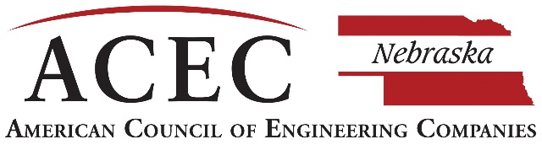

2020 ENGINEERING E XCELLENCE AWARDS

CALL FOR

**ENTRIES**

2020 Engineering Excellence Awards

Once a year, the American Council of Engineering Companies of Nebraska celebrates those projects exhibiting the best of the best – the most innovative engineering projects in the state of Nebraska.

ACEC Nebraska’s Engineering Excellence Awards provide firms an opportunity to obtain statewide recognition and to showcase their talent and expertise. We encourage your firm to submit projects for consideration. All submitted projects are rated on the basis of uniqueness and originality; future value to the engineering profession; social, economic, and sustainable development considerations; complexity; and successful fulfillment of the client/owner’s needs, including schedule and budget.

The 2020 Engineering Excellence Award winners will be recognized at our annual gala held on **April 16, 2020**. All firms are invited to join us as we celebrate the projects that have demonstrated innovation, complexity, and value. Winning firms are encouraged to invite their clients to join us as we honor the outstanding efforts of engineers who are improving the quality of life for all Nebraskans.

There are four (4) areas of awards to be presented:

* **GRAND AWARD –** Awarded to the highest-rated project of all categories in the state of Nebraska.
* **HONOR AWARDS –** Awarded to projects receiving outstanding distinction among all categories.
* **MERIT AWARDS –** Awarded to projects of exceptional merit among all categories.
* **CATEGORY WINNERS –** Awarded to the highest-rated project for each category.

Please contact the ACEC Nebraska office with any questions or for additional information. I look forward to seeing your submissions!

Have fun and good luck!



Jeanne McClure

Executive Director, ACEC Nebraska

**Judges/Criteria**

A distinguished panel of judges with backgrounds from engineering, architecture, state and federal government, media, academia, and the military review the projects. Judges score the top projects in all categories and determine the tier of winners.

**Awards & Certificates**

As part of the entry fee, ACEC Nebraska will provide one (1) firm award for each project. If member firms are interested in purchasing additional firm and/or client awards, this can be arranged through ACEC Nebraska. A request to order additional awards will be sent to winning firms.

**Submission Guidelines – Due Date: November 1, 2019**

* Complete the fill-in Word document Entry Form, add photos, any support images, and sign.
* Have your Owner/Client and Owner’s Representative sign the separate Signature Form.
* Create a PowerPoint slide template (examples included).
* Use included Checklist to ensure submission is complete for judging.
* Name and save the document with the **Category letter (SPACE) Firm Name (SPACE) followed by Project Name.** Project Name can be abbreviated if necessary.

Example: C Firm Name Project Title

***Eligibility***

* Project completion or disclosure within date range of Nov. 1, 2017 – Oct. 31, 2019.
* ANY FIRM, ACEC NE member or non-member, engaged in the private practice of engineering or surveying.
* Any ACEC NE member firm for any project completed anywhere in the world with Nebraska-based work.
* Non-member firm projects completed in Nebraska.

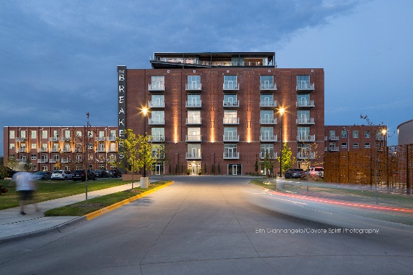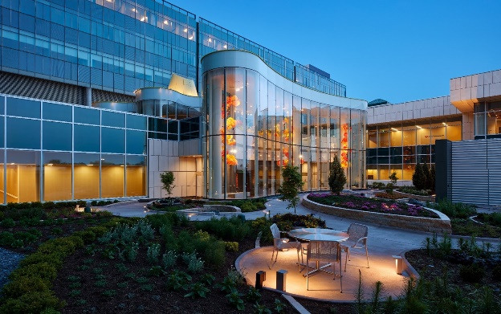

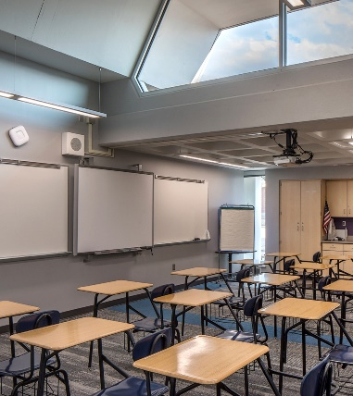

**Entry Fee**

* **$400** – ACEC NE Members working on a project anywhere in the world.
* **$600** – ACEC National Members who are not ACEC NE Members submitting a Nebraska-based project.
* **$800** – Nebraska-based, non-ACEC members submitting a Nebraska-based project.
* **$225** – Small Firm Projects
* **$200** – First-time submission or first time submitting after at least 5 years*

**\*First Time or 5-year Return**

If your firm is submitting for the first time, or if your firm has not submitted a project for at least 5 years, there is a special entry fee of $200**. This special rate applies to ACEC NE members only.**

**Payment Options:**

Check can bemade payable *to ACEC Nebraska***. Please send entry fees postmarked by the due date (November 1, 2019) to:** ACEC Nebraska**,** 211 N. 14th Street**,** Lincoln, NE 68508.

**Judging Criteria Prompts**

Each submission will be evaluated based on the following five categories, which are key elements of the project description text in the electronic Entry Form. These questions are intended to help you brainstorm award submittal content to effectively address each category of judging criteria. They are not meant to be directly answered in your submittal and some questions may not apply to your entry.

**1.ORIGINAL OR INNOVATIVE APPLICATION OF NEW OR EXISTING TECHNIQUES** (Rating – 20%)

* Does the entry demonstrate the use of a new science or a breakthrough in general knowledge of engineering?
* Does the entry represent a unique application of new or existing technology, techniques, materials or equipment?
* How was the solution developed for this project different from a similar project?

**2.FUTURE VALUE TO THE ENGINEERING OR SURVEYING PROFESSION** (Rating – 20%)

* Will the entry redefine current engineering or surveying thinking?
* How could someone else use what your firm did to solve a similar problem?

**3.SOCIAL, ECONOMIC, AND SUSTAINABLE DESIGN CONSIDERATIONS** (Rating 20%)

* Do the solutions identified produce secondary benefits of value to the community and/or environment?
* Does the entrant’s approach provide society with social, economic, or sustainable development benefits?
* Does the entrant’s contribution to the project improve the health, safety, or welfare of the public or affected environment?

**4.COMPLEXITY** (Rating – 20%)

* Did the entry successfully address highly complex criteria or unique problems?
* Were extraordinary problems of site, location, hazardous conditions, project requirements, or similar elements present?
* Did the entry require the use of out-of-the-ordinary technology or ingenuity for achievement of the project’s goals?

**5.EXCEEDING CLIENT/OWNER NEEDS** (Rating – 20%)

* Did the entrant successfully engage the client/owner in the overall project development process?
* Was the solution cost-effective? How did the project save money?
* How did the final cost relate to the original budget estimate?
* How closely does the entrant’s solution meet the total goals of the client/owner?
* How does the project exceed the original goals? Was the client’s schedule met? Did you save time with the design or technology?

**Important Dates to Remember**

**November 1, 2019**

Final date to submit award materials to ACEC Nebraska.

**December 2019**

Judging will be held and winners notified.

**January 3, 2020**

Deadline to submit for ACEC National awards. Visit the ACEC National website for more information. https://www.acec.org/awards-programs/engineering-excellence-awards/

**April 16, 2020**

Winners will be announced during the ACEC Nebraska Engineering Excellence Awards at A View on State in Omaha.

*Winners will be notified in late December.

*Winning submissions will be featured in the *Omaha-World Herald* and the *Midlands Business Journal* during Engineering Week – February 15 - 21, 2020.

## Reasons to Submit an Engineering Excellence Award

* Demonstrates pride in your firm and work.
* Provides the opportunity and platform for promotion of the project and your firm.
* Confirms your client’s beliefs in your design of new ideas and innovative solutions.
* Provides statewide publicity for your project, firm, and client.
* Increases your exposure to the public during Engineering Week (E-Week).
* Provides opportunity to submit your project to the ACEC national competition for greater recognition and promotion.
* To be recognized and honored at a prestigious awards gala that celebrates the latest engineering accomplishments across the state of Nebraska.

