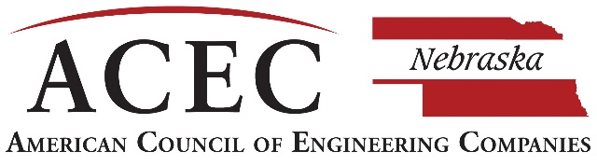
2023 ENGINEERING E XCELLENCE AWARDS
CALL FOR ENTRIES

2023 Engineering Excellence Awards
OWNER/CLIENT SIGNATURE PAGE

Submitting Firm Information
Firm Name Click here to enter text.
Firm Representative Click here to enter text.
Project Name Click here to enter text.

Project Client/Owner(s)
I believe the work of the engineer meets the intended uses and expectations for the project and hereby grant permission to enter this project in the ACEC Nebraska 2021 Engineering Excellence Awards competition, and authorize its publication. I confirm the project was substantially completed and ready for use between November 1, 2019 and October 31, 2022.

Client/Owner Representative’s Name: Click here to enter text.
Title: Click here to enter text.
Address: Click here to enter text.
City: Click here to enter text. State: Click here to enter text. Zip: Click here to enter text.
Phone: Click here to enter text. Fax: Click here to enter text.
E-mail: Click here to enter text.

Signature: Click here to enter text. Date: Click here to enter text.
Type in or insert a scanned signature.

