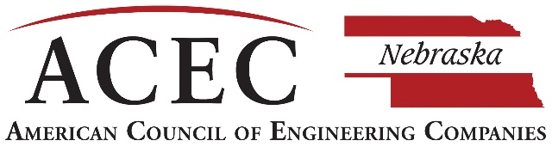

**2023 ENGINEERING E XCELLENCE AWARDS**

CALL FOR **ENTRIES**

2023 Engineering Excellence Awards

Every year the American Council of Engineering Companies of Nebraska celebrates those projects exhibiting the best of the best – the most innovative engineering projects produced by our firms here in Nebraska.

The goal of the Engineering Excellence Awards program is to convey to the engineering and construction industry, government officials, and the general public the contributions that consulting engineering firms make to society and our local communities. The EEA program is another opportunity for firms to obtain recognition for their work and to showcase their talent and expertise. And, firms have an opportunity to acknowledge the contribution of clients and to recognize individuals who have provided the thinking and leadership that make a project successful.

We encourage your firm to submit projects for consideration. All submitted projects are rated on the basis of uniqueness and originality; future value to the engineering profession; social, economic, and sustainable development considerations; complexity; and successful fulfillment of the client/owner’s needs, including schedule and budget. **This year’s deadline to submit is September 9, 2022!**

There are four (4) areas of awards to be presented:

* **GRAND AWARD –** Awarded to the highest-rated project of all categories in the state of Nebraska.
* **HONOR AWARDS –** Awarded to projects receiving outstanding distinction among all categories.
* **MERIT AWARDS –** Awarded to projects of exceptional merit among all categories.
* **CATEGORY WINNERS –** Awarded to the highest-rated project for each category.

Please contact the ACEC Nebraska office with any questions or for additional information. I look forward to seeing your submissions!

Have fun and good luck!



Jeanne McClure

Executive Director, ACEC Nebraska

**Judges/Criteria**

A distinguished panel of judges with backgrounds from engineering, architecture, state and federal government, media, academia, and the military can review the projects. Judges score the top projects in all categories and determine the tier of winners.

**Awards & Certificates**

As part of the entry fee, ACEC Nebraska will provide one (1) award for each project. Additional awards can be ordered

**Submission Guidelines – Due Date: September 9, 2022**

* Complete the Entry Form, add photos, any support images, and sign.
* Have your Owner/Client and Owner’s Representative sign the separate Signature Form.
* Create a PowerPoint slide template (examples included).
* Use included Checklist to ensure submission is complete for judging.
* Name and save the document with the **Category letter (SPACE) Firm Name (SPACE) followed by Project Name.** Project Name can be abbreviated if necessary.

Example: “C Firm Name Project Title”

***Eligibility***

* Project completion or disclosure within date range of Nov. 1, 2020 – October 31, 2022.
* ANY FIRM, ACEC NE member or non-member, engaged in the private practice of engineering or surveying.
* Any ACEC NE member firm for any project completed anywhere in the world with Nebraska-based work.
* 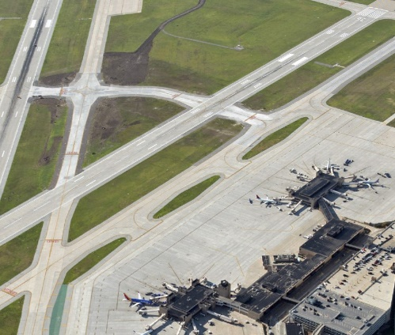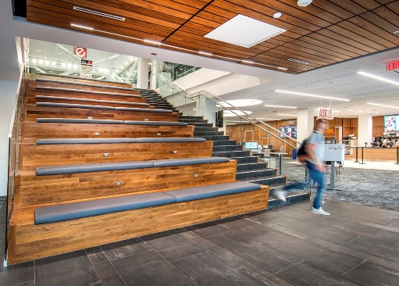Non-member firm projects completed in Nebraska.



**Entry Fee**

* **$400** – ACEC NE Members working on a project anywhere in the world.
* **$600** – ACEC National Members who are not ACEC NE Members submitting a Nebraska-based project.
* **$800** – Nebraska-based, non-ACEC members submitting a Nebraska-based project.
* **$225** – Small Firm Projects*
* **$200** – First-time submission or first time submitting after at least 5 years**

**\*Small Firm Projects**

Any ACEC NE engineering or surveying firm up to 25 employees is eligible to compete against other small firm projects.

**\*\*First Time or 5-year Return**

If your firm is submitting for the first time, or if your firm has not submitted a project for at least 5 years, there is a special entry fee of $200**. This special rate applies to ACEC NE members only.**

**Payment Options:**

Check can bemade payable *to ACEC Nebraska***. Please send entry fees postmarked by the due date (September 9, 2022) to: ACEC Nebraska, 635 S. 14th Street, Suite 315, Lincoln, NE 68508.**

**Judging Criteria Prompts**

Each submission will be evaluated based on the following five categories, which are key elements of the project description text required in the electronic Entry Form. Some questions may not apply to your entry.

**1.UNIQUENESS AND/OR INNOVATIVE APPLICATION OF NEW OR EXISTING TECHNIQUES** (Rating – 20%)

* Does the entry demonstrate the use of a new science or a breakthrough in general knowledge of engineering?
* Does the entry represent a unique application of new or existing technology, techniques, materials, or equipment?

**2.FUTURE VALUE TO THE ENGINEERING PROFESSION AND ENHANCED PUBLIC AWARENESS/ENTHUSIASM OF THE ROLE OF ENGINEERING** (Rating – 20%)

* Will the entry redefine current engineering thinking?
* Will the entry increase public awareness/enthusiasm about the role of engineering in their everyday lives?

**3.SOCIAL, ECONOMIC, AND SUSTAINABLE DESIGN CONSIDERATIONS** (Rating 20%)

* Do the solutions identified produce secondary benefits of value to the community environment?
* Does the entrant’s approach provide society with social, economic, or sustainable development benefits?
* Does the entrant’s contribution to the project improve the health, safety, or welfare of the public or affected environment?

**4.COMPLEXITY** (Rating – 20%)

* Did the entry successfully address highly complex criteria or unique problems?
* Were extraordinary problems of site, location, hazardous conditions, project requirements, or similar elements present?
* Did the entry require the use of out-of-the-ordinary technology or ingenuity for achievement of the project’s goals?

**5.SUCCESSFUL FULFILLMENT OF CLIENT/OWNER NEEDS** (Rating – 20%)

* Did the entrant successfully engage the client/owner in the overall project development process?
* Did the entrant introduce an economical and cost-effective solution?
* How did the final cost relate to the original budget estimate?
* How closely does the entrant’s solution meet the total goals of the client/owner?
* Did the entrant meet the client’s time schedule?

**Important Dates to Remember**

**September 9, 2022**

Final date to submit award materials to ACEC Nebraska.

**December 2022/January 2023**

Judging will be held and winners notified.

**January 13, 2023**

Deadline to submit for ACEC National awards. Visit the ACEC National website for more information. https://www.acec.org/awards-programs/engineering-excellence-awards/

**February 19-25, 2023**

Winners will be announced during National Engineers Week.

**April 27, 2023**

Winners will be honored during the ACEC Nebraska Engineering Excellence Awards at A View on West Shores in Waterloo.

*Winning submissions will be featured in the *Omaha-World Herald* and the *Midlands Business Journal* during Engineering Week – February 19-25, 2023.

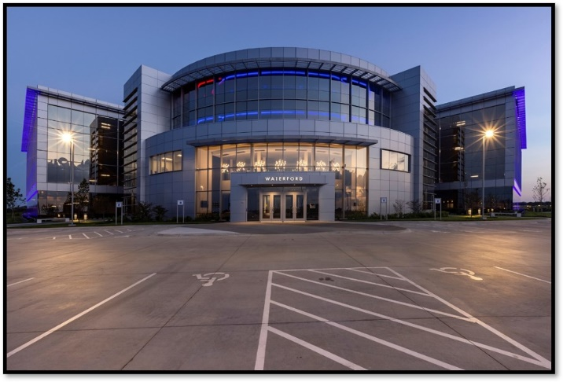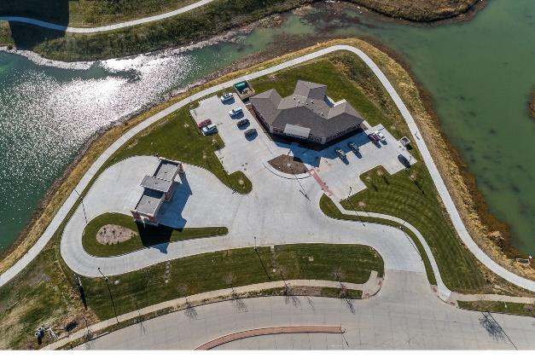

## Reasons to Submit an Engineering Excellence Award

* Demonstrates pride in your firm and work.
* Provides the opportunity and platform for promotion of the project and your firm.
* Confirms your client’s beliefs in your design of new ideas and innovative solutions.
* Provides statewide publicity for your project, firm, and client.
* Increases your exposure to the public during Engineering Week (E-Week).
* Provides opportunity to submit your project to the ACEC national competition for greater recognition and promotion.
* To be recognized and honored at a prestigious awards gala that celebrates the latest engineering accomplishments across the state of Nebraska.

